Geometry Concepts Name___________________

Quiz 2-1

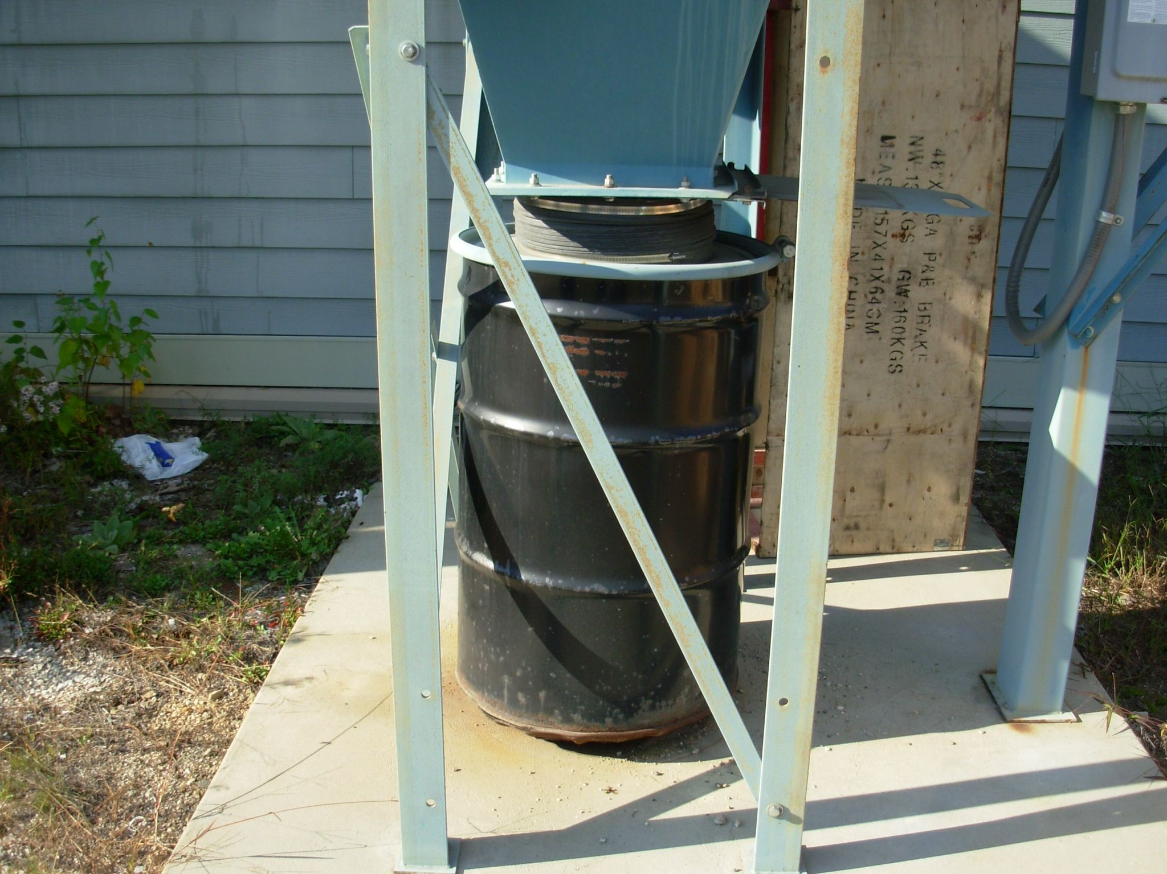

Part 1- Multiple Choice (Draw the figures if you need a visual)

1. Two or more angles that add up to 180°.

a. Complementary b. Supplementary c. Perpendicular d. Parallel

2. Angles next to each other and share a side.

a. Right b. Equal c. Adjacent d. Obtuse

3. A line or segment that intersects two or more other lines.

a. Transversal b. Line c. Segment d. Parallelogram

Part 2 - True or False

4. Complementary angles always have to be next to each other. ___________

5. When a transversal intersects parallel lines only two different sized angles are formed. ___________

6. The symbol to show that lines are parallel is an arrow on the lines. __________

Part 3 -Fun Stuff



**Assume the lines that look parallel above are indeed parallel.**

7. Name two pairs of angles that are vertical to each other.

8. Name two pairs of angles that are equal to each other.

9. Name two pairs of angles that are supplementary to each other.

Bonus 1. Describe one method for remembering the difference between complementary and supplementary.

Bonus 2. Which score is best for a round of golf; 3 under par, even, or 6 over par?