Geometry Concepts Name__________________

Quiz 1-3

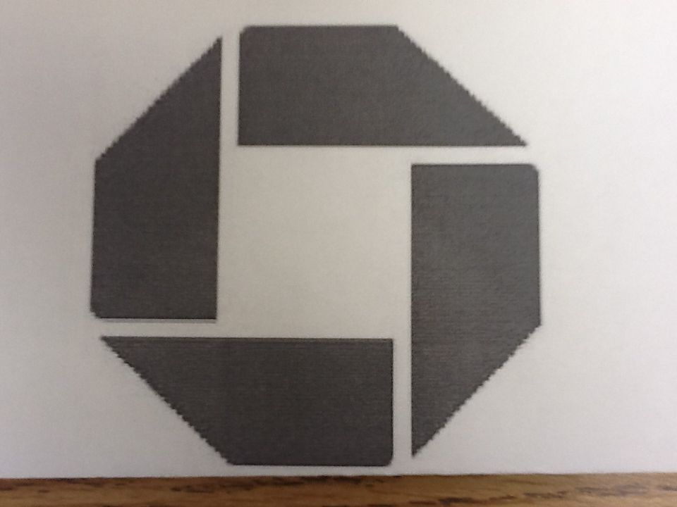

Part 1- Symbols are Everywhere

Match the symbol with the figure it represents.

1. Angle ______

2. Point ______

3. Ray ______

4. Perpendicular ______

5. Segment ______

6. Right angle ______

7. Parallel ______

8. Line ______

9. Plane ______

.

A. $⊥$

B. $∠$

C. .

D.

E.

F.

G. 

H.

I.

Part 2 – Angle of Truth



10. Use your protractor to find the measure of _________

11. Use your protractor to find the measure of _________

12. What is $∠DAB$ + $∠CAD$? _________

Bonus 1

Angles DAB and CAD have a special relationship. What do we call that relationship?

Bonus 2

What type of shape is ABCD?

Bonus 3

What is Mr. Cicero and Mr. Osborne’s favorite pastime?