Lesson 2-4 Triangles

In this unit, we will explore the most important aspects of the most common polygons.

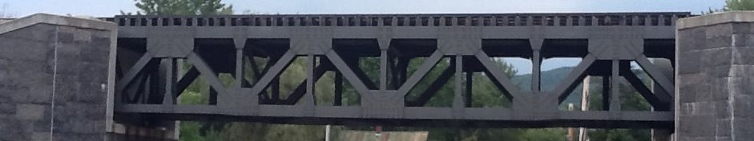

The simplest of all polygons, yet the most versatile. The triangle is the building block of almost all shapes and it’s usefullness in the world is vast.

For the triangle, you’ll discover today:

* What is the sum of the measures of its angles?
* What is it called when all the sides are the same length?
* Are the angles the same when the sides are the same?

Phase 1 – The sum of the angles inside a triangle

Let’s start with the angles inside the triangle. Grab the activity from your teacher.

Now you know.

The sum of the angles inside a triangle is always ___________

Phase 2 – A triangle with three equal sides

Now let’s check out the sides of a triangle.

1. Grad some spaghetti (or is it linguini?).

2. Cut three pieces the exact same length

3. Glue the pieces to some paper

4. Compare your triangle to everyone else’s.

A triangle with three all sides equal is called an _______________________________

Phase 3 – What else is true about an equilateral triangle?

Measure all three angles of your spaghetti triangle with a protractor.

An equilateral triangle is also ________________________________

Phase 4 – Practice with what you’ve learned

Find the measure of each missing angle.



What would you call this figure? (Use your new vocabulary)



*There’s a sticker in it for you if you read this and can tell me what a line is called that intersects two or more other lines.