Geometry Concepts Name___________________

Quiz 2-2

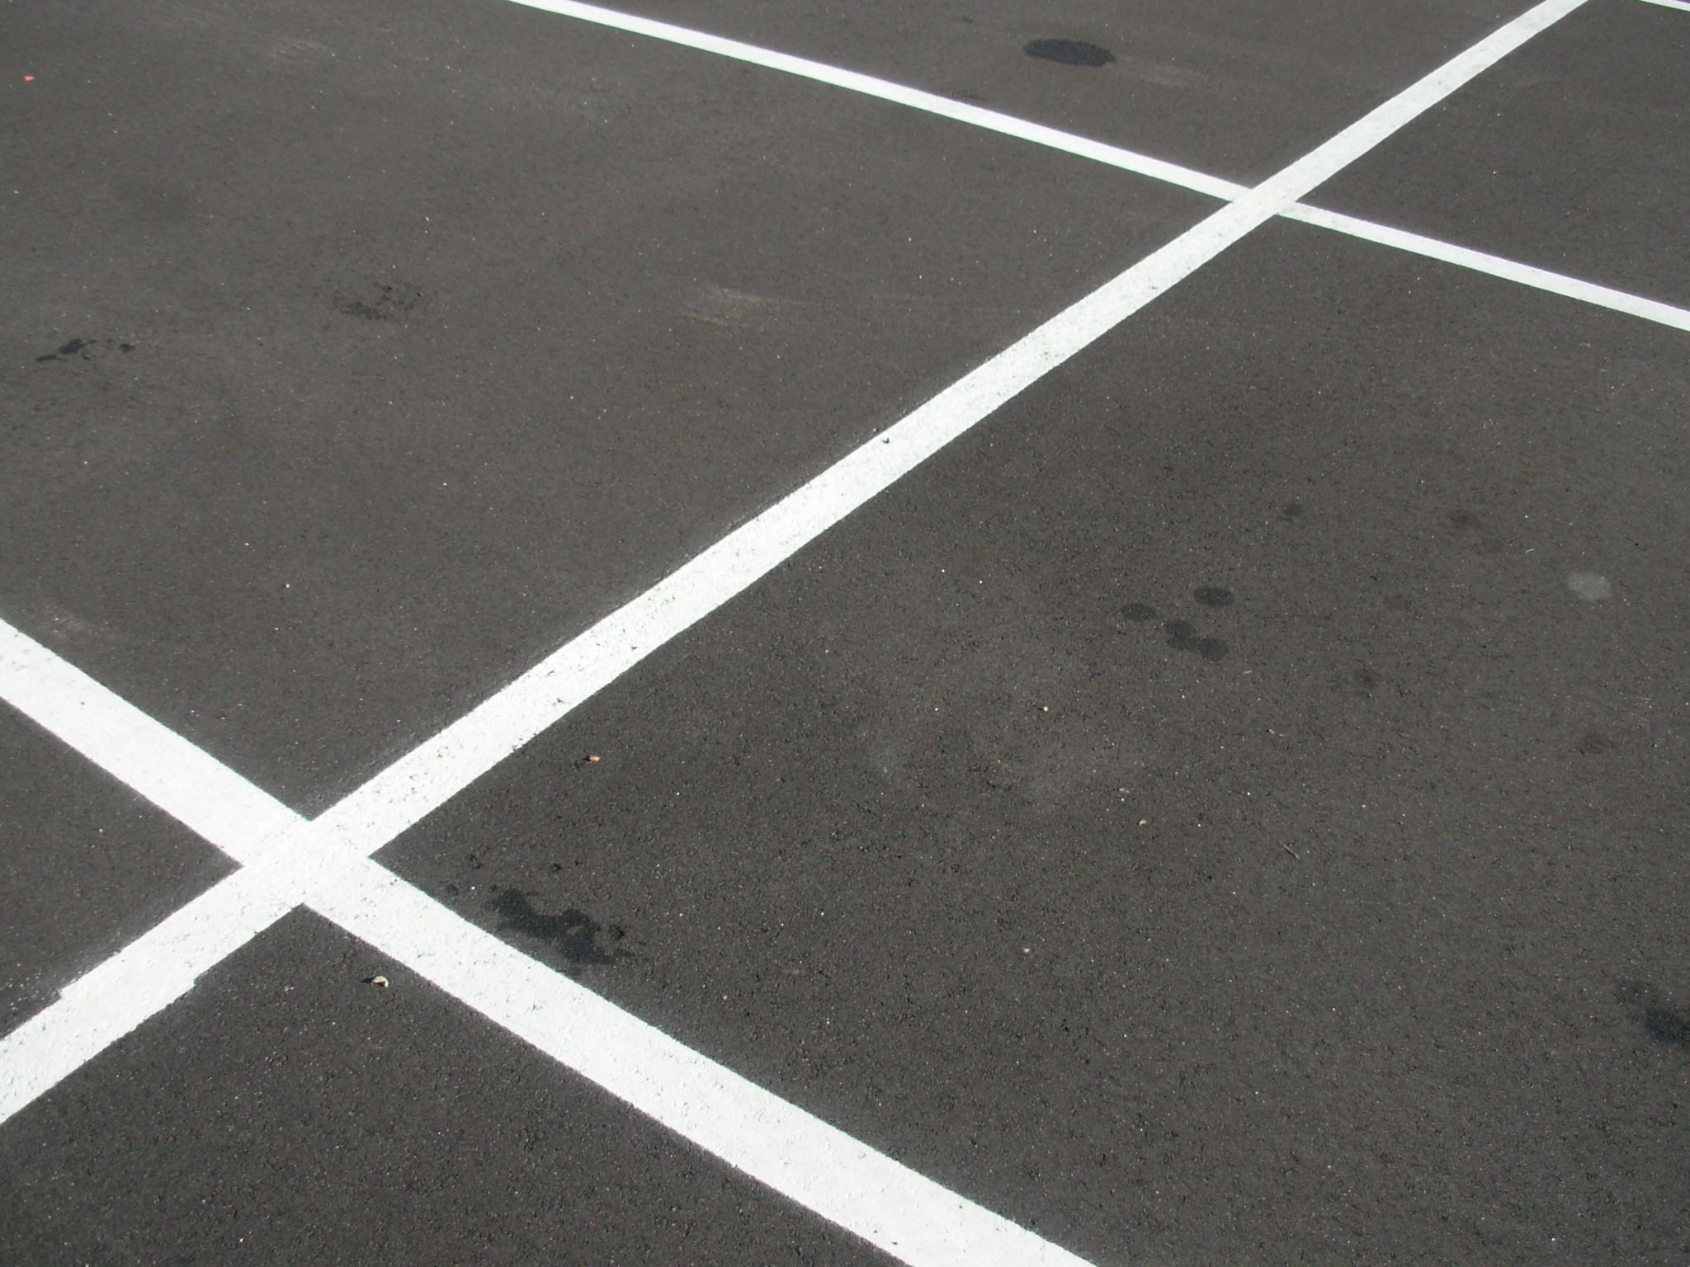

Part 1- Matching (match the word to the correct definition) 1pt each

1. Equiangular ______

2. Supplementary ______

3. Transversal ______

4. Complementary ______

5. Polygon ______

6. Triangle ______

7. Equilateral ______

A. Two or more angles that sum to 90°

B. All sides of a polygon are equal.

D.  A closed shape with no curves and a minimum of three sides.

E. Two or more angles that sum to 180°

F. A three sided polygon

G. A line that intersects two or more other lines.

H. All angles of a polygon are equal

Part 2 - True or False (1 pt each)

8. A polygon can have two sides. ___________

9. A polygon can have 2000 sides. ___________

10. If a triangle is equilateral then it is also equiangular. __________

Part 3 – You like it, you love it, you want some more of it.

Find the measure of the missing angles. (2 pts each)

11. 12.

 

13. 14.





Bonus 1

What’s the name of a 300 sided polygon?