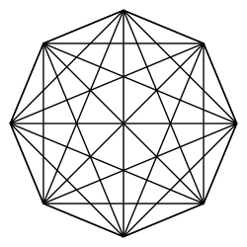
Geometry Concepts
Unit 1 – Student designed questions from Video
Study guide

1. What has an endpoint and goes forever in one direction?

2. What is it called when a segment goes forever in two directions?

3. What is impossible to do from a point and still be on the point?

4. How many dimensions does a point have?

5. What are the points at the end of a segment called?

6. What is represented with a dot and can be used with a partner to form a line segment?

7. How many dimensions does a line segment have?

8. What do two letters with a line segment over them mean?

9. How far can you move on a line segment?

10. What is the symbol for a ray?

11. What did Mr. Khan say we could have used as a name for a point?

12. What is the difference between a line segment and a line?

13. How many ways are there to name a line segment?

14. What has two dimensions and goes forever in those dimensions?

15. How thick is a plane?

16. Thinker – If two rays have the same endpoint what is created?

